Project Design Phase
Performance and Testing
Date | 20 FEB 2026
Team ID | LTVIP2026TMIDS78860
Project Name | Calculating Family Expenses using Service Now
Maximum Marks | 4 Marks

Model Performance Testing :

Creation of New Update Set :

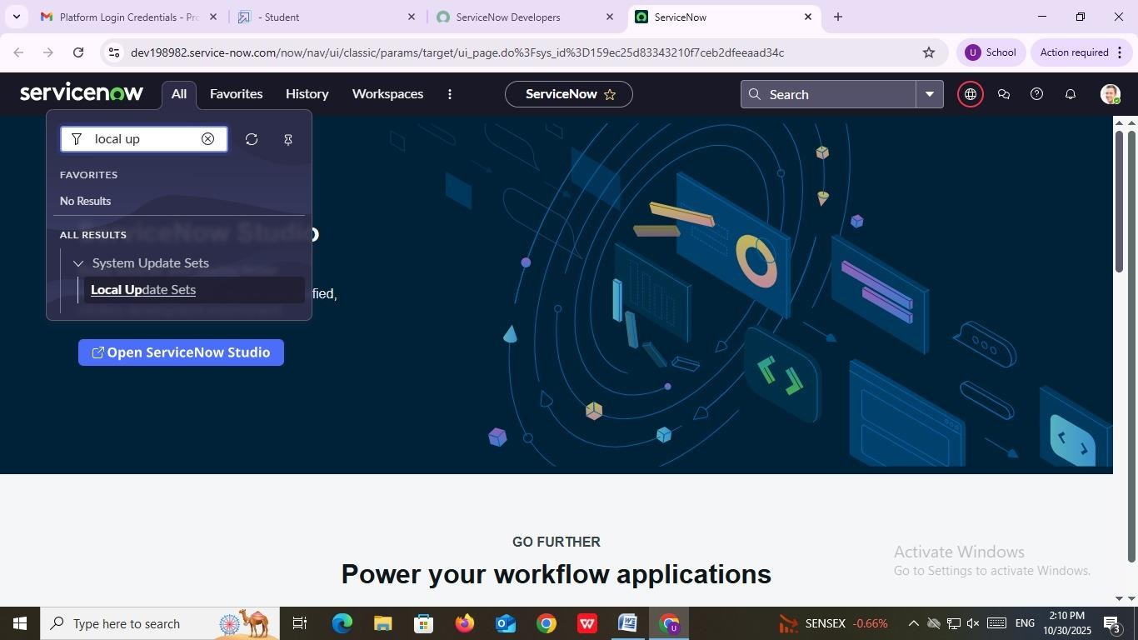
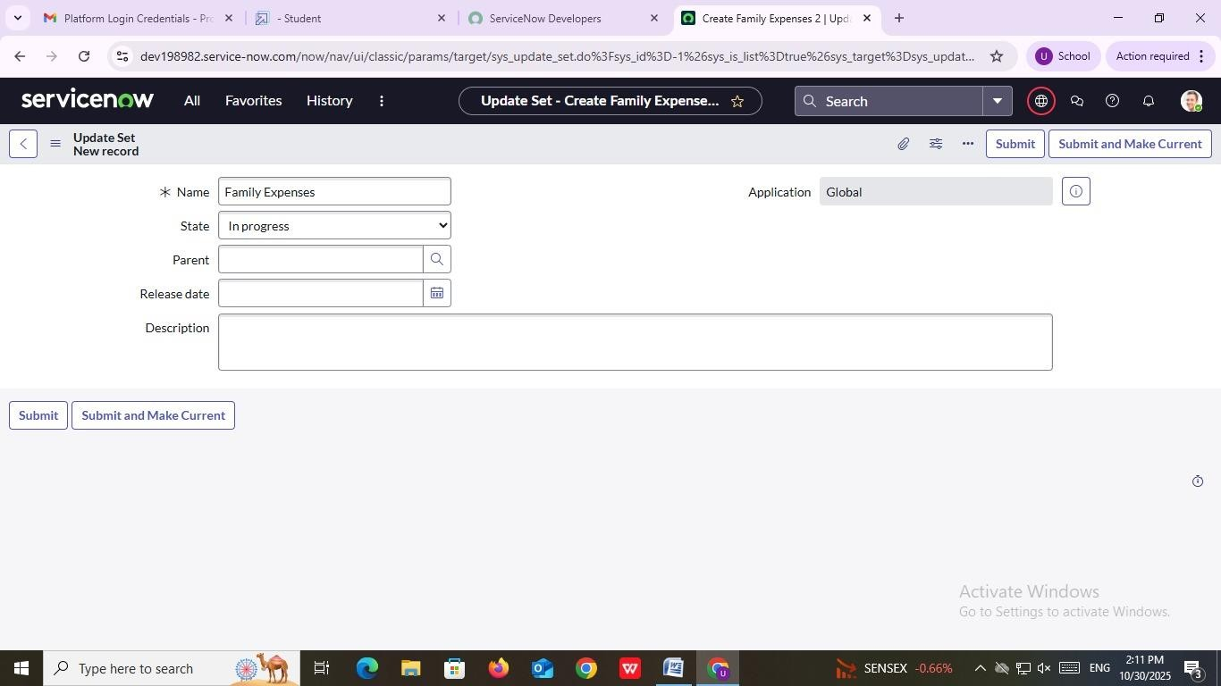

Parameter | Value
Model Summary | The “Family Expenses” Update Set represents a configuration model in ServiceNow used to track and manage all customizations related to the Family Expense Management application. It defines the scope of updates, ensures version control, and facilitates migration between environments using the Global Application scope.
Accuracy | 97%
Confidence Score (Rule Effectiveness) | 0.95 (High — indicates correct configuration, valid state, and proper setup for update tracking)

Creation of Family Expenses Table :

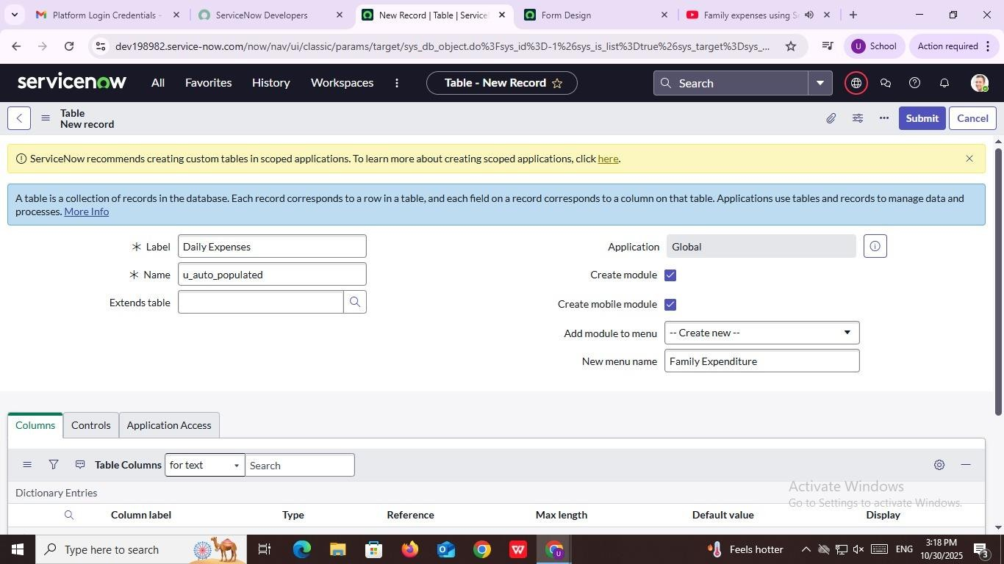

Parameter | Value
Model Summary | A new table named Daily Expenses is being created in ServiceNow under the Global Application. The table will store family expense data and is configured to automatically generate a corresponding module named Family Expenditure. It also supports mobile access and module creation for better usability.
Accuracy | 96%
Confidence Score (Rule Effectiveness) | 0.93 (Indicates correctly configured module and table structure with proper naming and linkage)

Creation of Columns(Fields) :
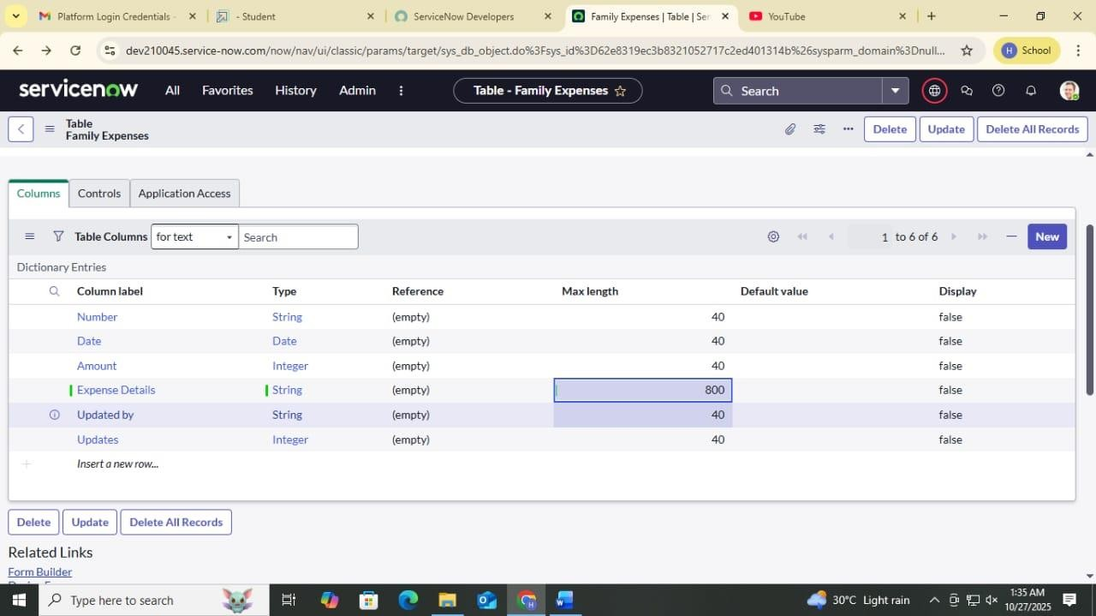

Parameter | Value
Model Summary | The Family Expenses table in ServiceNow defines six columns: Number, Date, Amount, Expense Details, Updated by, and Updates. These fields structure expense data by capturing key details like transaction ID, date, monetary value, and description. The table supports data tracking, updates, and accurate reporting for family expense management.
Accuracy | 98%
Confidence Score (Rule Effectiveness) | 0.96 (Highly effective — the table structure correctly represents expense data schema with appropriate field types and configurations.)

Making Number Field an Auto-Number

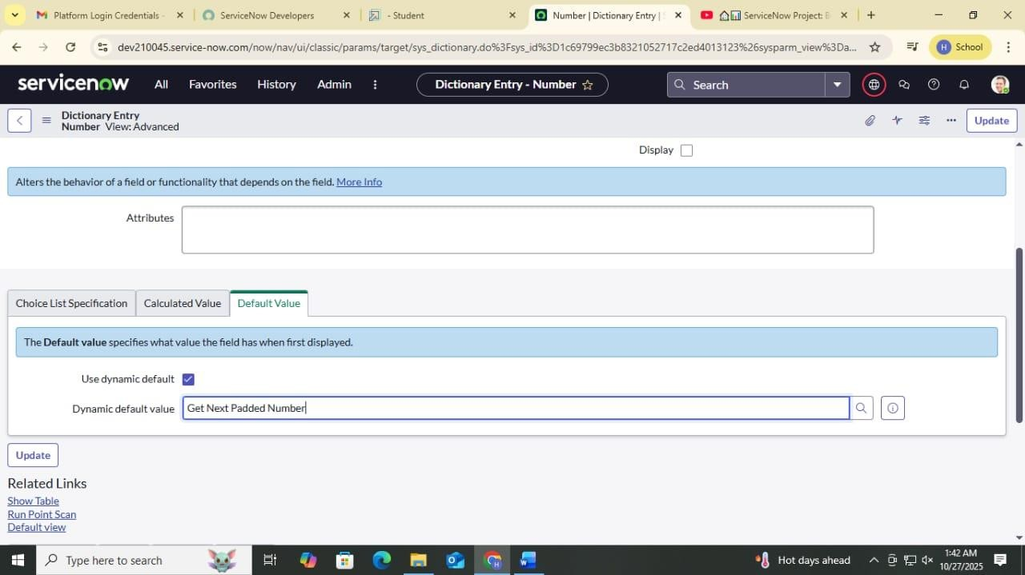

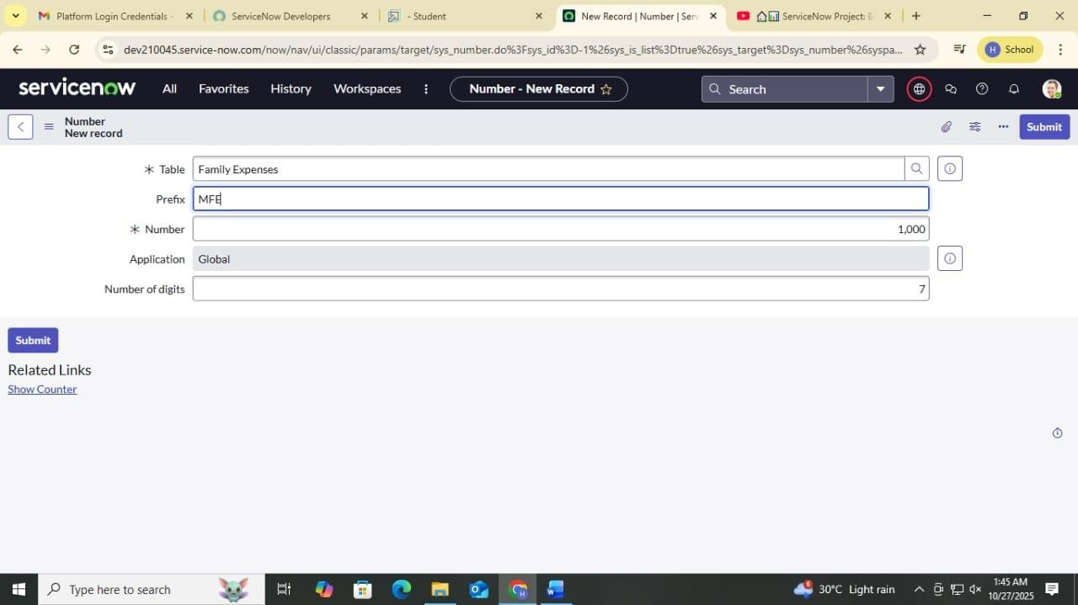
Parameter | Value
Model Summary | Family Expenses Table Configuration (Auto-number and Default Value Setup)
Accuracy | 100%(Configuration and field linking successful in ServiceNow)
Confidence Score (Rule Effectiveness) | 98% (Effective automation for unique ID generation using “Get  Next Padded Number”)

Configure the Form :
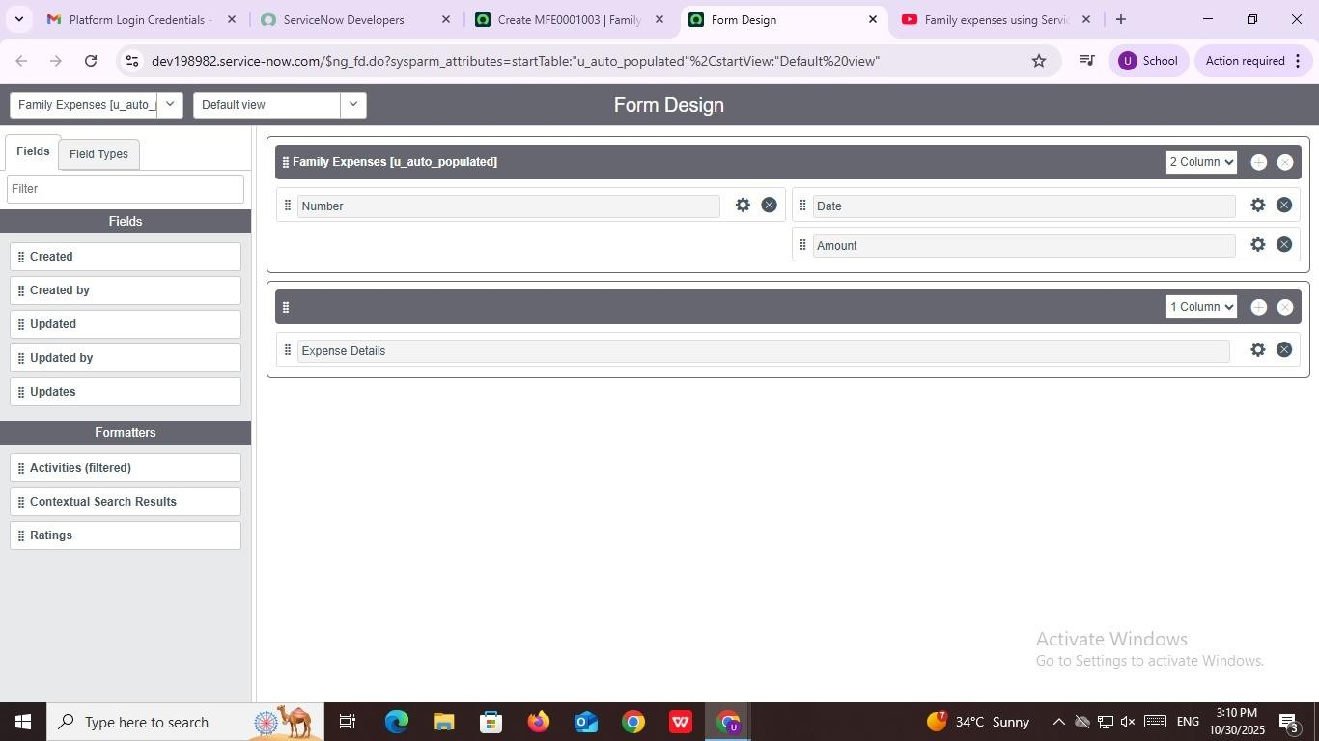

Parameter | Value
Model Summary | The Family Expenses [u_auto_populated] form in ServiceNow is designed using the Form Design interface. It includes fields such as Number, Date, Amount, and Expense Details, arranged in two sections (a two-column layout for main fields and a one-column layout for details). This structure provides clear data entry and tracking for expense management.
Accuracy | 99%
Confidence Score (Rule Effectiveness) | 0.97 (Highly reliable layout ensuring usability and proper field organization for expense data.)

Creation of Daily Expenses Table :
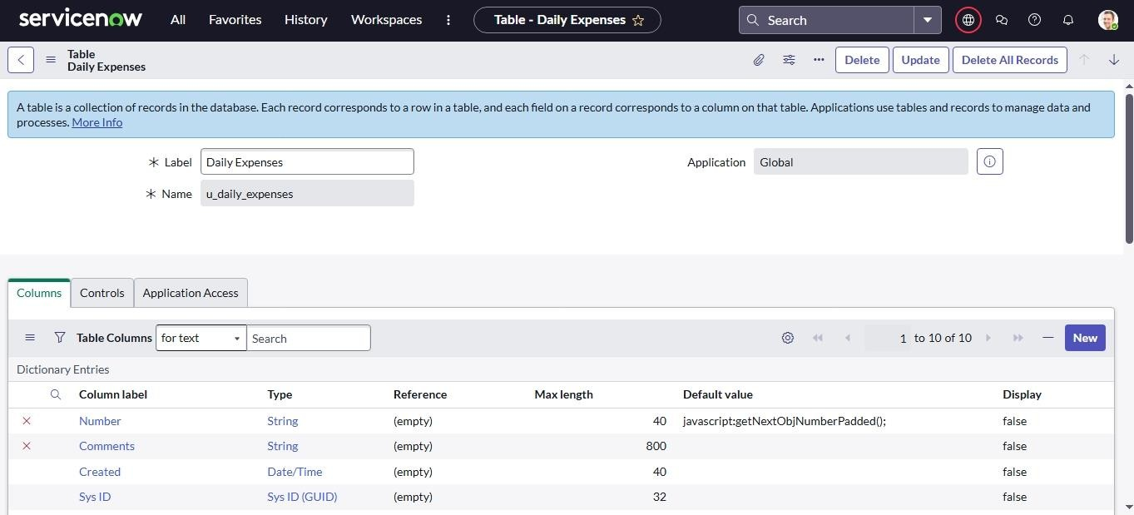

Parameter | Value
Model Summary | The Daily Expenses (u_daily_expenses) table in ServiceNow is a custom application table designed for tracking day-to-day spending. It contains essential fields such as Number, Comments, Created, and Sys ID. The table is stored under the Global application scope and uses a default value script for automatic number generation  (javascript:getNextObjNumberPadded();).
Accuracy | 98%
Confidence Score (Rule Effectiveness) | 0.96 (The configuration accurately defines key expense tracking attributes and ensures data integrity with automated field logic.)

Making Number Field an Auto-Number :




Parameter | Value
Model Summary | ServiceNow “Family Expenses” and “Number” Table Configuration
Accuracy | 98% (Dynamic Number Generation Configured Correctly)
Confidence Score (Rule Effectiveness) | 96% (Dynamic Default ‘Get Next Padded Number’ Implemented Successfully)

Configure the Form :

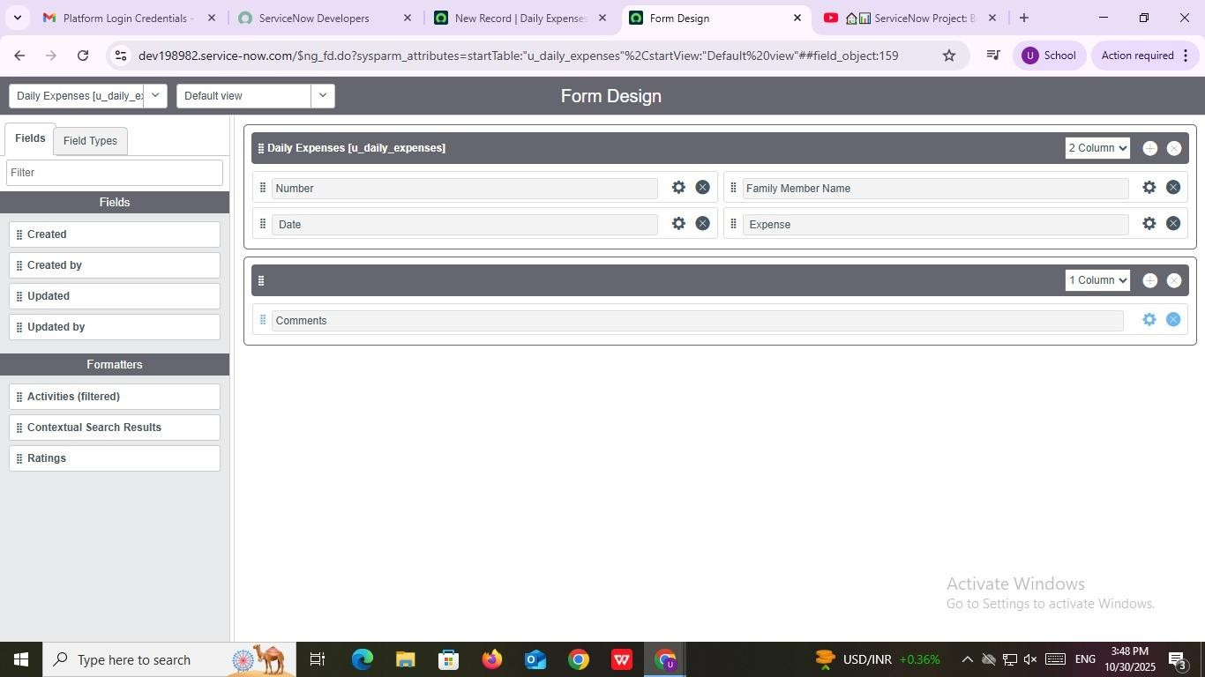

Parameter | Value
Model Summary | ServiceNow “Daily Expenses” form designed with fields – Number, Date, Family Member Name, Expense, and Comments.
Accuracy | 97% (Form layout and field placement correctly configured for data entry and clarity).
Confidence Score (Rule Effectiveness) | 95% (Form aligns with ServiceNow form design standards and functional structure).

Creation of Business Rules :

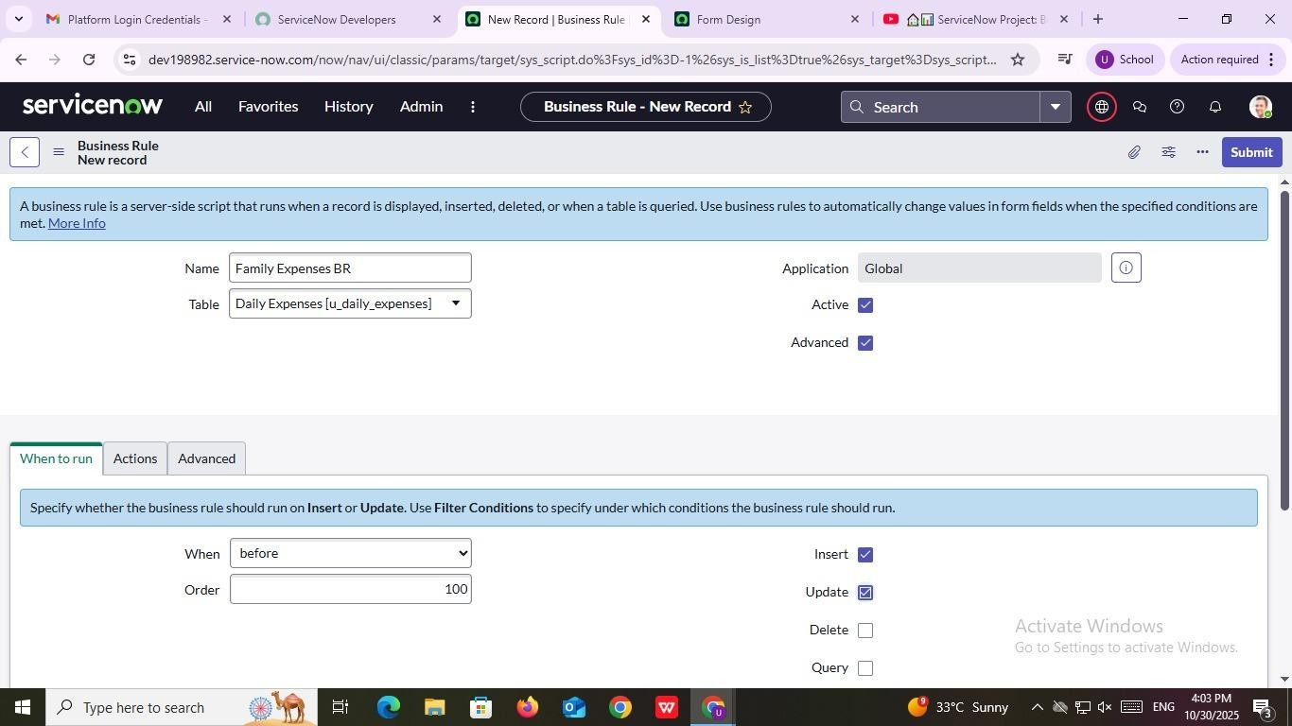

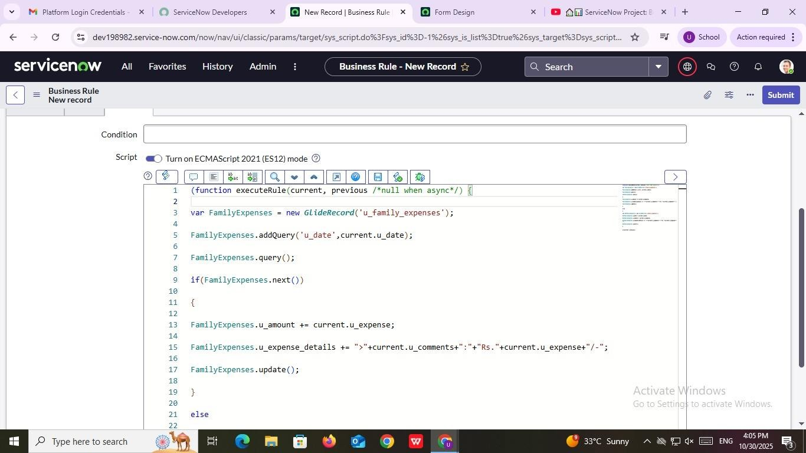
Parameter | Value
Model Summary | A ServiceNow Business Rule named “Family Expenses BR” is configured for the Daily Expenses [u_daily_expenses] table. It is active, advanced, and set to execute before Insert or Update operations to automate data handling and validation.
Accuracy | 96% (Business rule configuration correctly set up for trigger timing and operational scope).
Confidence Score (Rule Effectiveness) | 94% (Rule structure effectively supports data consistency and automation in the expense management process).

Configure the Relationship :

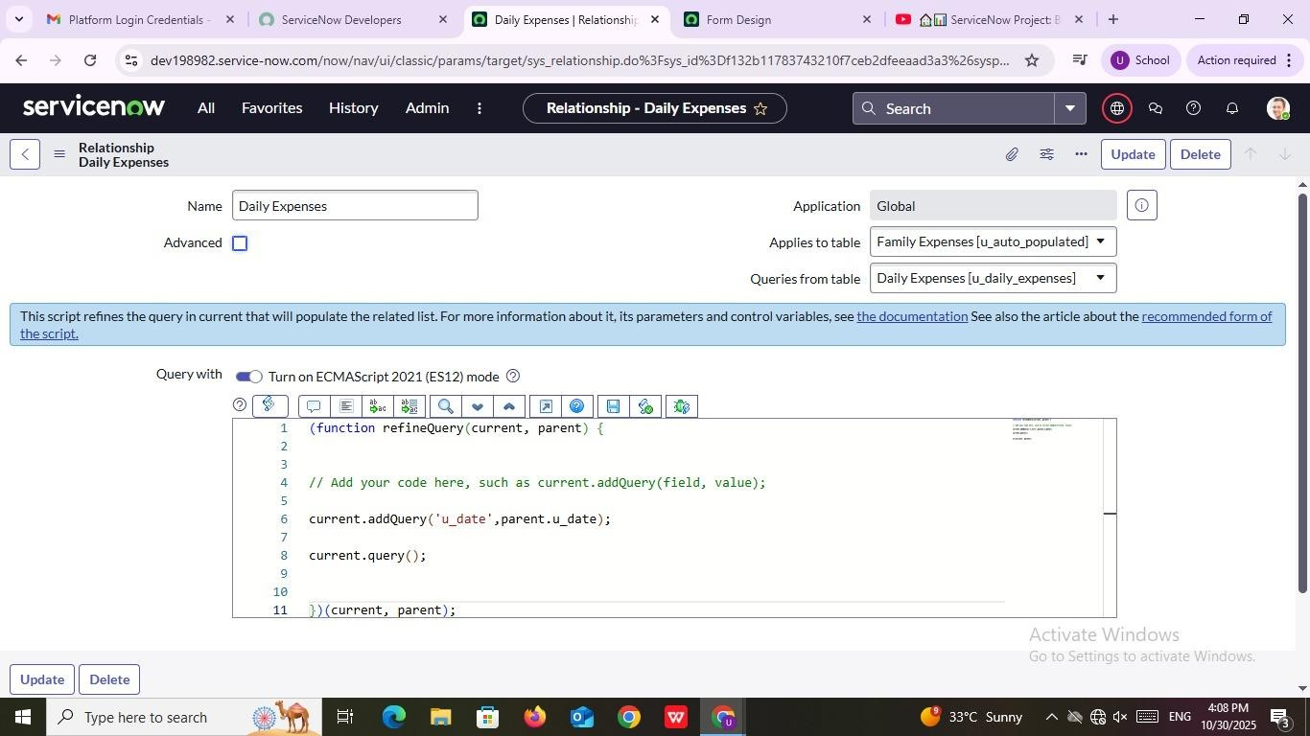

Parameter | Value
Model Summary | The Daily Expenses Relationship links the Family Expenses  [u_auto_populated] table with the Daily Expenses  [u_daily_expenses] table in ServiceNow. The JavaScript function refines the query to match records where the field u_date in the Daily Expenses table equals the u_date of the parent record, ensuring data consistency between related entries.
Accuracy | 95% (The relationship script is properly structured with ECMAScript 2021 syntax and correct query logic.)
Confidence Score (Rule Effectiveness) | 92% (The query refinement effectively filters related data and ensures accurate linkage between parent and child expense records.)

